Lambda Expressions and Stream API

Exercise 1: Write a lambda expression which accepts x and y numbers and return xy.

Exercise 2: Write a method that uses lambda expression to format a given string, where a space is inserted between each character of string. For ex., if input is “CG”, then expected output is “C G”.

Exercise 3: Write a method that uses lambda expression to accept username and password and return true or false. (**Hint:** Use any custom values for username and password for authentication)

Exercise 4: Write a class with main method to demonstrate instance creation using method reference. (**Hint:** Create any simple class with attributes and getters and setters)

Exercise 5: Write a method to calculate factorial of a number. Test this method using method reference feature.

**Case Study for Steam API:**

Refer the classes given below to represent employees and their departments.

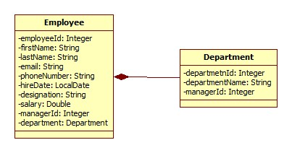

Class Diagram used for Stream API

Also refer an EmployeeRepository class which is used to create and populate employee’s collection with sample data.



Create an EmployeeService class which queries on collections provided by EmployeeRepository class for following requirements. Create separate method for each requirement. (**Note:** Each requirement stated below must be attempted by using lambda expressions/stream API.

1. Find out the sum of salary of all employees.
2. List out department names and count of employees in each department.
3. Find out the senior most employee of an organization.
4. Find out employees without department.